Project Planning Phase
Project Planning Template (Product Backlog, Sprint Planning, Stories, Story points)

Date | 27 June 2025
Team ID | LTVIP2025TMID53093
Project Name | HouseHunt: Finding Your perfect rental home
Maximum Marks | 5 Marks

Product Backlog, Sprint Schedule, and Estimation (4 Marks)

Sprint | Functional Requirement (Epic) | User Story Number | User Story / Task | Story Points | Priority | Team Members
Sprint- 1 | Registration | USN-1 | As a user, I can register with email, password, and type | 2 | High | Bhuvana  Team B
Sprint- 1 |  | USN-2 | As a user, I receive a confirmation email after registration. | 1 | High | Bhuvana
Sprint- 2 |  | USN-3 | As a user, I can register using Facebook. | 2 | Low | Team C
Sprint- 1 |  | USN-4 | As a user, I can register using Gmail. | 2 | Medium | Bhuvana
Sprint- 1 | Login | USN-5 | As a user, I can log in with my email and password. | 1 | High | Team D

Sprint- 2 | Dashboard | USN-6 | As a user, I can view my listed properties and filter them and then book them | 3 | High | Team C
Sprint- 2 | Admin approval | USN-7 | As a admin I can approve or reject owner registration | 3 | High | Team D
Sprint- 3 | Add/Edit/Delete property | USN-8 | As a user I can add, edit or delete my listed properties | 4 | High | Team B
Sprint- 3 | Image upload and Testing | USN-9 | As a user, I upload property imsges and team can test whole app | 2 | Medium | Bhuvana  TeamB  Team D  Team C

Project Tracker, Velocity & Burndown Chart (4 Marks)

Project Tracker Table

Sprint | Total Story Points | Duration | Sprint Start Date | Sprint End Date (Planned) | Story Points Completed | Sprint Release Date (Actual)
Sprint-1 | 20 | 6 Days | 12 Jun 2025 | 18 Jun 2025 | 20 | 18 Jun 2025
Sprint-2 | 20 | 6 Days | 19 Jun 2025 | 25 Jun 2025 | 18 (Estimated) | 25 Jun 2025
Sprint-3 | 20 | 6 Days | 26 Jun 2025 | 31 Jun 2025 | TBD | TBD

Velocity Calculation
Formula:
Velocity = Total Story Points Completed / Number of Sprints

- Sprint-1: 20
- Sprint-2: 18
- Sprint-3: 16
- Total Story Points = 54
- Number of Sprints = 3

Team Velocity = 54 / 3 = 18 Story Points per Sprint
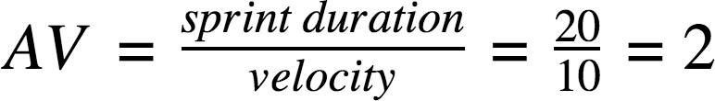
Team Velocity & Average Calculation

Story Points Completed Per Sprint

Sprint | Story Points Completed
Sprint-1 | 20
Sprint-2 | 18
Sprint-3 | 16
Total | 54

Average Story Points per Day

Assuming each sprint = 6 working days, then:

Average = Velocity / Sprint Duration
Average = 18 story points / 6 days = 3 story points per day

BURNDOWN CHART EXPLANATION
A Burndown Chart tracks the total remaining work (story points) against time (days). It helps monitor sprint progress and whether the team is on track to finish tasks within the sprint timeline.

- X-axis: Time (Sprint Days)
- Y-axis: Remaining Story Points
- Ideal line: Declines linearly from total points to zero
- Actual line: Shows real progress based on completed story points daily
- 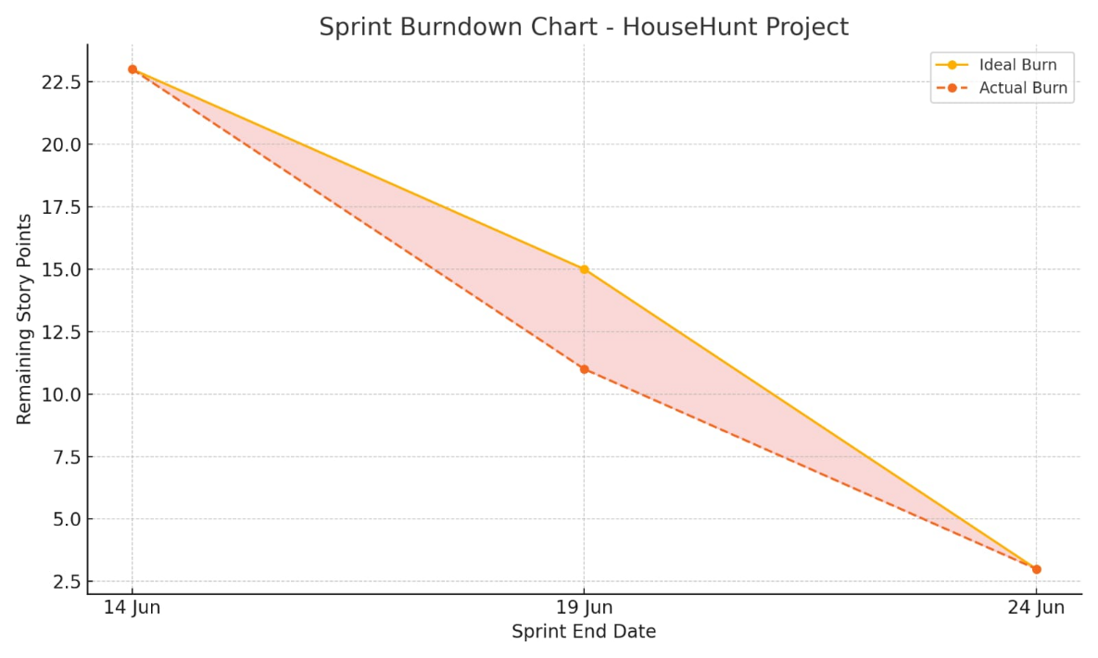
References

- Scrum Burndown Chart Overview
https://www.visual-paradigm.com/scrum/scrum-burndown-chart/
- Burndown Charts Tutorial
https://www.atlassian.com/agile/tutorials/burndown-charts
- Agile Project Management Guide
https://www.atlassian.com/agile/project-management
- How to Do Scrum with Jira Software
https://www.atlassian.com/agile/tutorials/how-to-do-scrum-with-jira-software
- Understanding Epics in Agile
https://www.atlassian.com/agile/tutorials/epics
- Introduction to Sprints
https://www.atlassian.com/agile/tutorials/sprints
- Agile Estimation Methods
https://www.atlassian.com/agile/project-management/estimation

